SW 3.2.2 – uSpirit – SRXL2 Protocol
Startup: 0% Throttle, green bar “OK”
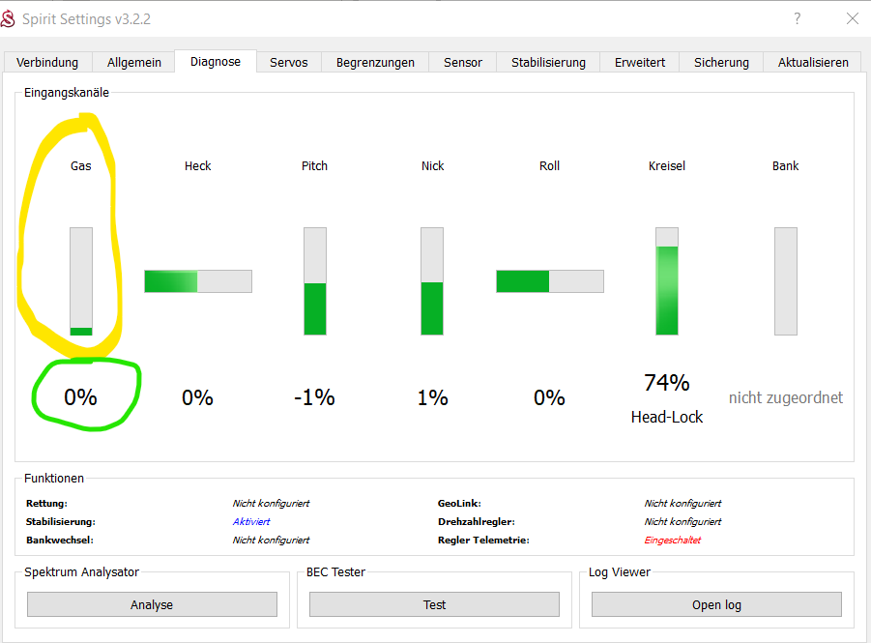
Normal Flight - Throttle: 71% - green bar “OK”
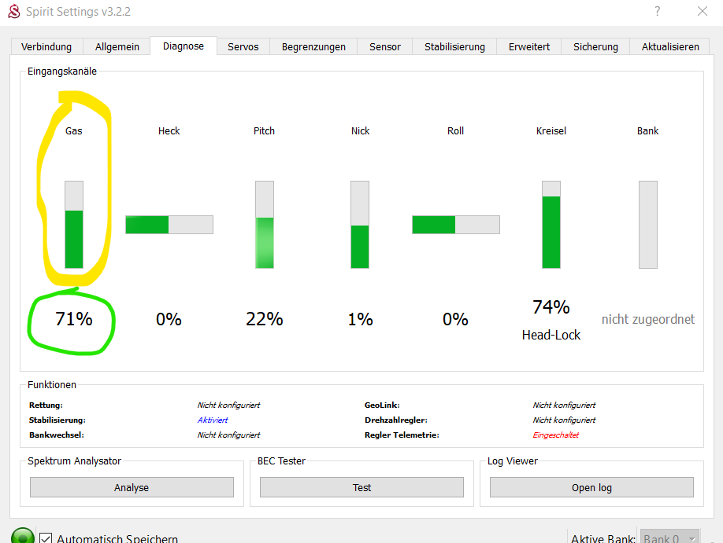
THROTTLE CUT “ – Throttle OK, green bar FALSE, also Motor DOESNOT STOP !!!!!!!!
